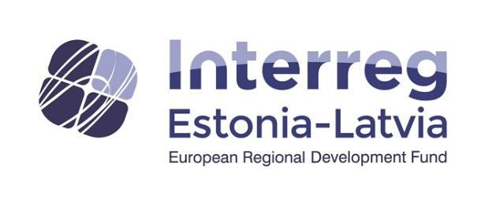
Study trip 28th until 30th of August 2018
NB! There can be changes in the programme!
Mulgimaa, Estonia 28.08.2018
12:00 OÜ Mõisaküla Masinatehas is a privately funded Estonian company and its products include various forestry, agricultural and utility machinery. http://mtm.ee/home/
13:00 lunch in dining room Siliina, Mõisaküla
14:15-15.00 Nuia PMT AS was founded in 1991. Main field of activity is manufacturing hydraulic cylinders and metal structures and equipment. The company has 75 employees and turnover in 2017 was MEUR 5,5. Our main clients are forestry-, agriculture- and construction machine manufacturers in Estonia, Finland, Sweden and Latvia. Nuia PMT also manufactures building structures as a subcontractor and various welded steel building constructions. Hydraulic cylinders are manufactured according to the specifications and diagrams provided by clients and on the basis of the construction methods developed by the company.
15:00 Karksi-Nuia tehnikakeskus/technic centre, provides a wide range of services in the technical field: Car spare parts, Car repair and maintenance, Car interior and exterior cleaning, waxing, polishing etc; sale, repair and maintenance of movers and sawmill, etc. http://www.mulgitehnikakeskus.ee/et
16:00- 17:00 Vine farm in Morna village, Mulgi municipality, Külastuse kestvus 1 tund.
17:30 Viljandi municipality – possible enterprises: OÜ Päikesepuu, Mulgi savikoda.
Arriving to the Männiku Metsatalu (Männiku forest cottage) , accomodation http://metsatalu.ee/eng/
20:00 Dinner
* OÜ= private limited company

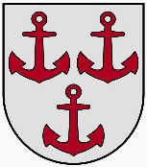
Wednesday, 29.08.2018.
7:45-8:30 breakfast
8.30 leaving from Männiku Metsatalu to Viljandi
9:00 Viljandi municipality – possible enterprises: Eziil
10:00 Leaving to Latvia
Salacgriva, Latvia 29.08.2018.
11:30 - 12:15 Visiting company “Grandeg” in Ainaži, The company manufactures pellet heating boilers for private houses and also for larger buildings more then 20 years. http://www.grandeg.lv/home/
12:30 – 13:30 Visit company “Dabas maize” (Nature Bread) http://www.dabasmaize.lv/ product tasting and tea (3,50 EUR per person).
13:30 – 14:30 Lamprei weir on Salaca river http://www.visitsalacgriva.lv/lv/ko-darit/negu-tacis/ and The Salacgriva Museum tells the story of a Lamprei fisherman's trademark.
14:30 – 15:30 Lunch
15:30 – 16:30 Visiting guest house „Bērziņi“ https://viesunamiem.lv/berzini
16:45 Arrival at the guesthouse “Kosīši”, taking rooms
17:00 – 19:00 Workshop (led by Liene Some - Tiesnese) to get to know better each other. Business skills promotion.
19:00 Dinner
30.08.2018
8:00 – 9:00 Breakfast, We go to Sernikon territory

Sernikon, Latvia 30.08.2018
Improve the quality of Your life at the Windy coast
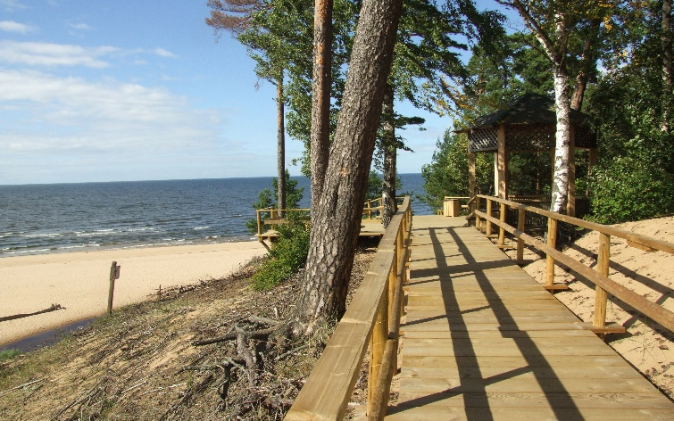
During the study visit in the territory of “Sernikon” (Carnikava and Saulkrasti municipality) You will meet 3 entrepreneurs who is helping to increase the reputation of Windy Coast near Riga as a recreation place to rest in holiday apartments, improve health and the look. It will be great opportunity to be inspired not just from the services they provide, but also to hear personal stories of creating new or improving existing business with the help of money allocated to implement local development strategy.
Draft programme
30th of August, 2018.
10:00 – 11:00 Rest in Your seaside hotel- Visiting the Strand Hotel in Saulkrasti and meet Solvita
11:00- 11:30 Drive from Saulkrasti to Carnikava (22 km)
11:30- 12:30 Be healed in brand new medicine center, Visiting the newly built medicine center and meet Kristīne
12:30- 12:45 Drive to lunch (1 km)
12:45- 13:30 Lunch
13:30- 14:00 Drive to Kalngale
14:00- 15:00 Get recovered and beautiful in the village, Visiting SPA “Pelikāns” and meet Ieva
15:00- Visiting Windy coast in Kalngale and back home ca 3 hours to Estonia/Abja-Paluoja.

